**ST. THEREZA NAMIRYANGO GIRLS’ BOARDING PRIMARY SCHOOL**

**END OF TERM I CONTINUOUS ASSESSMENT 2024**

**P.2 LITERACY**

**TIME ALLOWED: 2 HOURS 15 MINUTES**

**NAME___________________________________________STM__**

**SECTION A**

1. Write any one item used to clean the teeth.

**______________________________________________________**

1. Mention any one part of a plant used for decoration.

**______________________________________________________**

1. Why do we spread clothes under sunshine after washing them?

**________________________________________________________**

1. Apart from cuts, mention any other example of accidents that can happen at school.

**_______________________________________________________**

1. How can Sarah keep her cups and plates clean?

**______________________________________________________**

1. How are wings useful to a bird?

**_______________________________________________________**

1. Write any one example of vectors found in the latrines.

**_______________________________________________________**

1. Name one thing a clean home should have.

**_______________________________________________________**

1. Why do we boil water for drinking?

**________________________________________________________**

**The diagram below shows a tool used to carry out personal hygiene. Use it to answer questions 10 and 11.**



1. Name the above tool.

**______________________________________________________**

1. How is the above tool useful when carrying out personal hygiene?

**______________________________________________________**

1. Apart from sunshine, mention any other element of weather.

**______________________________________________________**

1. Why do babies need vitamins in their diet?

**_______________________________________________________**

14. Kitten is to cat as **_____________**is to cow.

15. How many eyes do you have?

**________________________________________________________**

1. Why do we do physical body exercises?

**_______________________________________________________**

17. Give the use of a broom when cleaning the classroom.

**_________________________________________________________**

18. Write the health activity done before eating food.

**_________________________________________________________**

19. How are eggs from ducks useful to people?

**_________________________________________________________**

**The diagram below shows the part of the human body.**

**Use it to answer questions 20 and 21.**

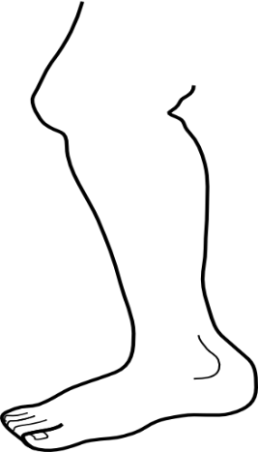

20. Give the use of the drawn part of the human body.

**______________________________________________________**

21. How can we keep the above part of the body clean?

**________________________________________________________**

22. Give any one disease we can get when we eat dirty food.

**________________________________________________________**

24. How can a P.2 child prevent the bad breath from the mouth?

**______________________________________________________**

25. Mention any one animal which feeds on grass as food.

**_______________________________________________________**

26. Why do we need pots at home?

**________________________________________________________**

27. Name this tool used for proper disposal of rubbish.

_**____________________**

28. Who cares for sick pupils in the sickbay?

**_______________________________________________________**

29. How does a fish move?

**________________________________________________________**

30. State one use of a knife to a mother at home.

**_________________________________________________________**

31. Give any one way of keeping food safe for a longtime

without getting spoilt.

**________________________________________________________**

32. Why do people keep donkeys at home?

**________________________________________________________**

33. Name the insects which provide us with honey.

**________________________________________________________**

34. Apart from stones, mention any other example of things

found in our environment.

**______________________________________________________**

35. Why do we give first aid to a casualty?

**______________________________________________________**

36. Name these items used in the kitchen.

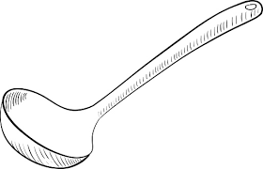

**________________________________________________________**

37. How are broken bottles dangerous to pupils at school?

**_________________________________________________________**

38.What will happen to Peter’s teeth if he eats a lot of sweets?

**_________________________________________________________**

39. Draw one item made out of wood.

40. Who cooks food at school?

**_________________________________________________________**

**SECTION B**

41. (a)What do we call things which do not have life?

**___________________________________________________**

(b) Write any two examples of things which do not have life.

(i)**__________________________________________**

(ii) **_________________________________________**

(c) Why are stones called non-living things?

**______________________________________________________**

42. (a) Mention any two tools used to keep the compound clean.

(i)**__________________________________________**

(ii) **_________________________________________**

(b) How can a P.2 child keep the school compound clean?

**______________________________________________________**

(c) Why should the school compound be kept clean?

**_____________________________________________________**

43. (a) Give any two groups of vulnerable people.

(i)**__________________________________________**

(ii) **_________________________________________**

(b) Name the group of vulnerable people who need

to be given medicine in time.

**_____________________________________________________**

(c) How can we care for vulnerable groups of people like the babies?

**____________________________________________________**

44. **The diagram below shows the parts of a plant. Study it carefully and use it to answer the given questions.**

**L**

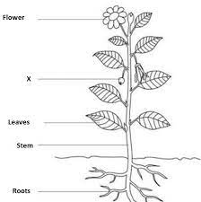

**M**

**N**

**P**

1. Name parts marked;

**L** : **______________**

**M** : **______________**

**N** : **______________**

1. How is part marked **P** useful to people?

**__________________________________________________**

45. (a) Write any two items used to clean the hair.

(i)**_________________________________________**

(ii) **________________________________________**

(b) How can Martha keep her hair clean?

**___________________________________________________**

1. Mention the parasites Tom can get if he does not keep his hair clean.

**__________________________________________________**

46. (a) What are domestic birds?

**_____________________________________________________**

(b) Give any two examples of domestic birds.

1. **_______________________________________**
2. **_______________________________________**

(c) Why do people keep domestic birds like ducks?

**_____________________________________________________**

47. (a) How can a P.2 child keep her uniforms clean?

1. **_________________________________________________**
2. **_________________________________________________**
3. Why do we iron clothes?

**__________________________________________________**

1. Write one item used to clean our clothes.

**____________________________________________________**

48.(a) Give any two examples of common diseases.

(i) **____________________________________________________**

(ii) **___________________________________________________**

1. Why should a P.2 child sleep under a treated mosquito net at night?

**_____________________________________________________**

1. State one danger of common diseases to people.

**______________________________________________________**

49. **The diagram below shows the parts of a fish. Use it to answer the questions that follow.**

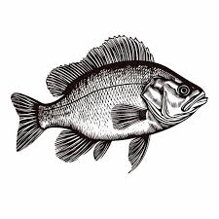

1. Name parts marked;

A : ________________

C : ________________

**A**

**B**

**C**

(b) How is part marked B useful to a fish?

**______________________________________________________**

(c) Where does a fish live?

**_____________________________________________________**

50. (a) Write any two examples of garden tools.

(i)**____________________________________________________**  (ii)**____________________________________________________**

(b) How are these garden tools useful to a farmer?

(i) watering can; **_______________________________**  (ii) hoe; **______________________________________**

51. **Match animal in A to its habitat in B.**

**A B**

(i) lion hutch

(ii) domestic rabbit den

(iii) cow house

(iv) man kraal

**Correct order**

1. lion : **____________________**
2. domestic rabbit ; **_______________**
3. cow; **_____________**
4. man; **____________**_

52. **The diagram below shows a food storage. Use it to**

**answer the questions that follow.**

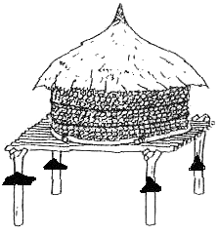

1. Name the food storage drawn above.

**_______________________________________________________**

1. Write any two examples of food stored in the above storage.
2. **________________________________________________**
3. **_________________________________________________**

(c) Why do we keep food in the above storage?

**______________________________________________________**

53. (a) Mention any two parts of an insect.

(i) **________________________** (ii) **______________________**

(b) How are spiracles useful to an insect?

**_____________________________________________________**

(c) Write any one example of useful insects.

**____________________________________________________**

54. (a) Name any two sources of water.

(i) **________________________** (ii) **______________________**

1. Write any one container used to store water.

**_____________________________________________________**

1. Why do people need water at home?

**_____________________________________________________**

55. (a) Draw these things we make

|  |  |
| --- | --- |
|  |  |
| **basket** | **pot** |

(b) Why do people make these crafts?

(i) chairs**:_____________________________________**

(ii) balls**:_______________________________________**